A CURRICULUM VITAE

TAKASHI KUNIHARA

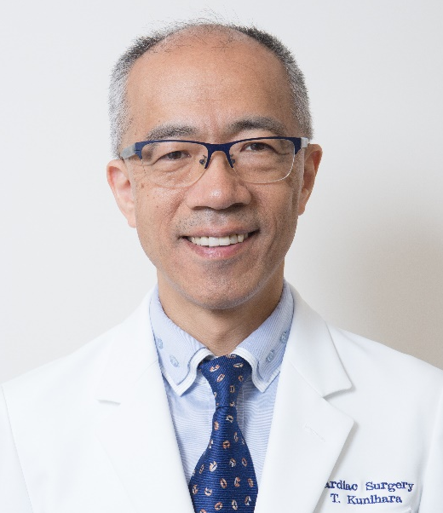

Correspondent Address: Department of Cardiac Surgery,
The Jikei University School of Medicine
3-25-8 Nishishinbashi, Minato-ku, Tokyo 105-8461 Japan
TEL: 03-3433-1111 (int. 3500)
FAX: 03-5470-9375
E-mail: kunihara@jikei.ac.jp
Web site: http://shinzougeka.com

Education:
1971-77 Hinode Primary School
1977-80 Zoushigaya Junior High School
1980-83 Koishikawa Senior High School
1985-91 Hokkaido University School of Medicine

Professional Training and Employment:
1991-92 Hospital training as cardiovascular surgeon at National Sapporo Hospital, Japan
1992-93 Hospital training as general surgeon at Kuttyan Kosei Hospital, Japan
1993-94 Hospital training as general surgeon at Ohji General Hospital, Japan
1994-95 Associate in the Department of Cardiovascular Surgery and 2nd Department of Surgery, Hokkaido University Hospital, Japan
1995-96 Hospital training as cardiovascular surgeon at National Sapporo Hospital, Japan
1996-5/2000 Associate in the Department of Cardiovascular Surgery, Hokkaido University Hospital, Japan
8/2000-3/2003 Guest doctor in the Department of Thoracic and Cardiovascular Surgery, University Hospital of Saarland, Germany
4/2003- Associate in the Department of Cardiovascular Surgery, Hokkaido University Hospital, Japan
1/2004- Assistant professor in the Department of Cardiovascular Surgery, Hokkaido University Hospital, Japan
4/2007- Associate in the Department of Thoracic and Cardiovascular Surgery, University Hospital of Saarland, Germany
4/2008- Functional consultant surgeon in the Department of Thoracic and Cardiovascular Surgery, University Hospital of Saarland, Germany
4/2009- Consultant surgeon in the Department of Thoracic and Cardiovascular Surgery, University Hospital of Saarland, Germany
12/2013- Chief Consultant Cardiovascular Surgeon, The Cardiovascular Institute, Japan
11/2015/-5/2018/5 Part-time assistant professor at The Jikei University School of Medicine, Japan (concurrent post)
4/2016/-3/2018 Visiting Professor, Hokkaido University Hospital, Japan (concurrent post)
4/2016-3/2018 Clinical Professor, Tokyo Medical and Dental University, Japan (concurrent post)
8/2016-3/2019 Clinical professor at Dokkyo Medical University, Japan (concurrent post)
6/2018 Chairman and Professor of Department of Cardiac Surgery, The Jikei University School of Medicine, Japan

Qualification
1991 Passed examination of Japanese National Board
1995 Qualified physician of Japanese Surgical Society
1998 Active member of Japanese Society of Thoracic Surgery
1998 Passed the board examination of Japanese Society of Thoracic Surgery
2000 Degree of doctor of medical science (Promotion)
2004 Board certified cardiovascular surgeon in Japan
2005 Qualified instructor of Japanese Society of Thoracic Surgery
2007 Board certified cardiovascular surgeon in Germany
2009 Qualified instructor of Japanese Surgical Society
2012 German medical license (Approbation)
2014 German associate professor (Habilitation)
2015 Committee member of cardiovascular stroke society of Japan (President for 10th annual scientific meeting)
2015 Manager of Japanese society for arrhythmia surgery (facilitator for 34th annual scientific meeting)
2016 Councilor of Japanese heart rhythm society
2016 Sponsor for Winter Seminar for Cardiovascular Surgery
2018 Councilor of Japanese Society of Thoracic Surgery
2019 Councilor of Japanese Society for Vascular Surgery
2020 Representative of Japanese Surgical Society
2020 Councilor of Japanese Society for Cardiovascular Surgery
2020 Adult Domain Committee Member of The Asian Society for Cardiovascular & Thoracic Surgery

Degree:
2000 The doctoral thesis titled "Lazaroid Reduces Production of IL-8 and IL-1 Receptor Antagonist in the Postischemic Spinal Cord Injury" has already published in the world famous lournal; "The Annals of Thoracic Surgery 2000: 69; 792-798".

Grant:
1999 Transesophageal monitoring of spinal cord ischemia using Near-infrared spectrophotometry: #11877221 for scientific research, from the Japanese Ministry of Education
2015 Evaluation of Valsalva sinus and valvular function by various procedures of valve-preserving root replacement: Grants-in-aid for scientific research, Fundamental research (C) #15K10227
2019 Geometric evaluation of bicuspid aortic valve with optimal hemodynamics to develop novel annuloplasty ring: Grants-in-aid for scientific research, Fundamental research (C) #19K09252
2019 Multicenter study on the usefulness of mitral valvuloplasty with papillary muscle relocation for severe ischemic mitral regurgitation: Clinical Research Promotion Grant of Japanese Society for Cardiovascular Surgery

Prize:
2/1990 Eimatsui Takakuwa memorial scholarships
9/1999 Akiyama memorial oversea fellowship
12/1999 Uehara memorial foundation oversea fellowship
06/2016 Aortic valve repair summit 2016 award best video

Publications:

 |  | Japanese | English
Original article | Single author |  | 7
 | First author | 13 | 29
 | Second author or below | 20 | 59
Case report | Single author
 | First author | 8 | 2
 | Second author or below | 13 | 17
Review | Single author | 10
 | First author
 | Second author or below
Book | Single author
 | First author | 23 | 8
 | Second author or below | 2 | 4
Total |  | 89 | 126

Presentation (First author alone):

International congress 41
Domestic congress 182
International closed meeting/lecture 11
Domestic closed meeting/lecture 128

(Updated at 3rd January 2021)

